Zabbix Monitoring Setup on AWS EC2 using Docker
This document provides a standardized procedure to deploy Zabbix Monitoring using Docker on an AWS EC2 instance. It is intended for internal teams to quickly set up monitoring, alerts, and email notifications in development or production environments.
Architecture Overview
• AWS EC2 (Ubuntu) hosts Docker containers
• Zabbix Server, Web UI, and MySQL run as Docker containers
• Zabbix Agent 2 runs directly on the EC2 host
• Zabbix Server communicates with the agent via private IP
• Email alerts are sent using Gmail SMTP
Prerequisites
• AWS EC2 instance (Ubuntu 22.04 / 24.04)
• Docker & Docker Compose
• Inbound Security Group access
• Gmail account with App Password
Step 1: Launch AWS EC2 (Ubuntu)
- Launch EC2 → Ubuntu
- Attach Security Group with ports:
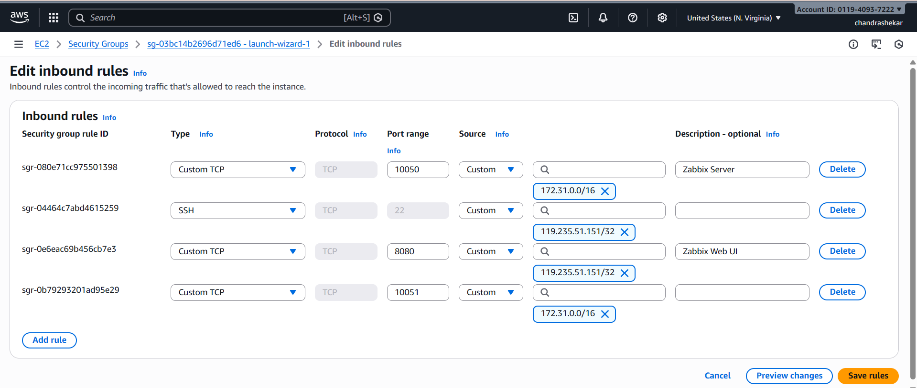
Security Group Configuration
Inbound Rules:
22 → SSH → Admin Public IP (/32)
8080 → Zabbix Web UI → Admin Public IP (/32)
10050 → Zabbix Agent → VPC CIDR (e.g., 172.31.0.0/16)
10051 → Zabbix Server → VPC CIDR (e.g., 172.31.0.0/16)
Note: Agent and Server ports are restricted to internal VPC access to avoid external exposure of monitoring services.
SSH into server:
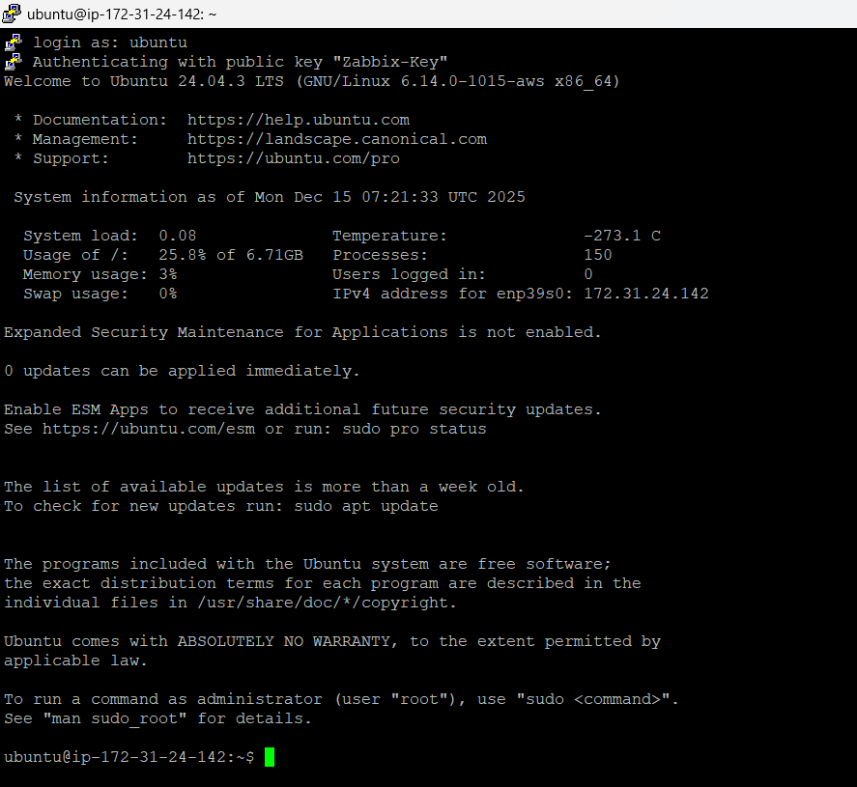
Step 2: Update Server
sudo apt update && sudo apt upgrade -y
Step 3: Install Docker
sudo apt install docker.io -y
sudo systemctl start docker

sudo systemctl enable docker
Allow ubuntu user to run docker:
sudo usermod -aG docker ubuntu
newgrp docker
Verify:
docker --version
docker ps
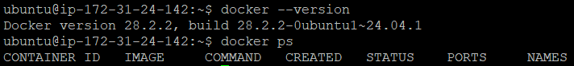
Step 4: Install Docker Compose
sudo apt install docker-compose -y
docker-compose –version
Zabbix Deployment Using Docker
Step 5: Create Zabbix Directory
mkdir zabbix-docker
cd zabbix-docker
Step 6: Create docker-compose.yml
version: '3.5'
services:
mysql-server:
image: mysql:8.0
container_name: zabbix-mysql
environment:
MYSQL_ROOT_PASSWORD: zabbix
MYSQL_DATABASE: zabbix
MYSQL_USER: zabbix
MYSQL_PASSWORD: zabbix
volumes:
- mysql_data:/var/lib/mysql
networks:
- zbx_net
zabbix-server:
image: zabbix/zabbix-server-mysql:ubuntu-7.4-latest
container_name: zabbix-server
environment:
DB_SERVER_HOST: mysql-server
MYSQL_DATABASE: zabbix
MYSQL_USER: zabbix
MYSQL_PASSWORD: zabbix
ports:
- "10051:10051"
depends_on:
- mysql-server
networks:
- zbx_net
zabbix-web:
image: zabbix/zabbix-web-nginx-mysql:ubuntu-7.4-latest
container_name: zabbix-web
environment:
DB_SERVER_HOST: mysql-server
MYSQL_DATABASE: zabbix
MYSQL_USER: zabbix
MYSQL_PASSWORD: zabbix
PHP_TZ: Asia/Kolkata
ports:
- "8080:8080"
depends_on:
- mysql-server
- zabbix-server
networks:
- zbx_net
volumes:
mysql_data:
networks:
zbx_net::
Save and exit.
STEP 7: Start Zabbix Services
docker-compose up -d
Verify Containers
docker ps
STEP 8: Access Zabbix Web UI
Open in browser:
http://<EC2_PUBLIC_IP>:8080
Default Login
- Username: Admin
- Password: zabbix
Login:
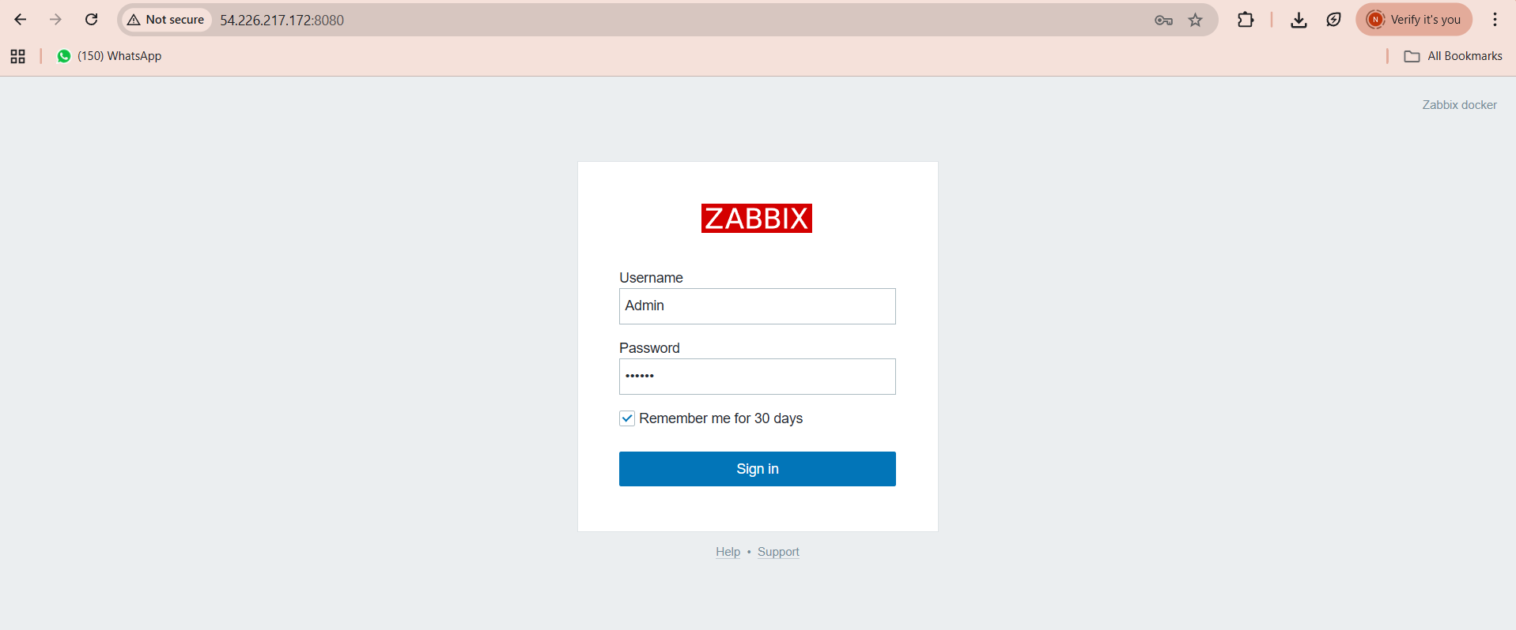
You should see the Zabbix dashboard
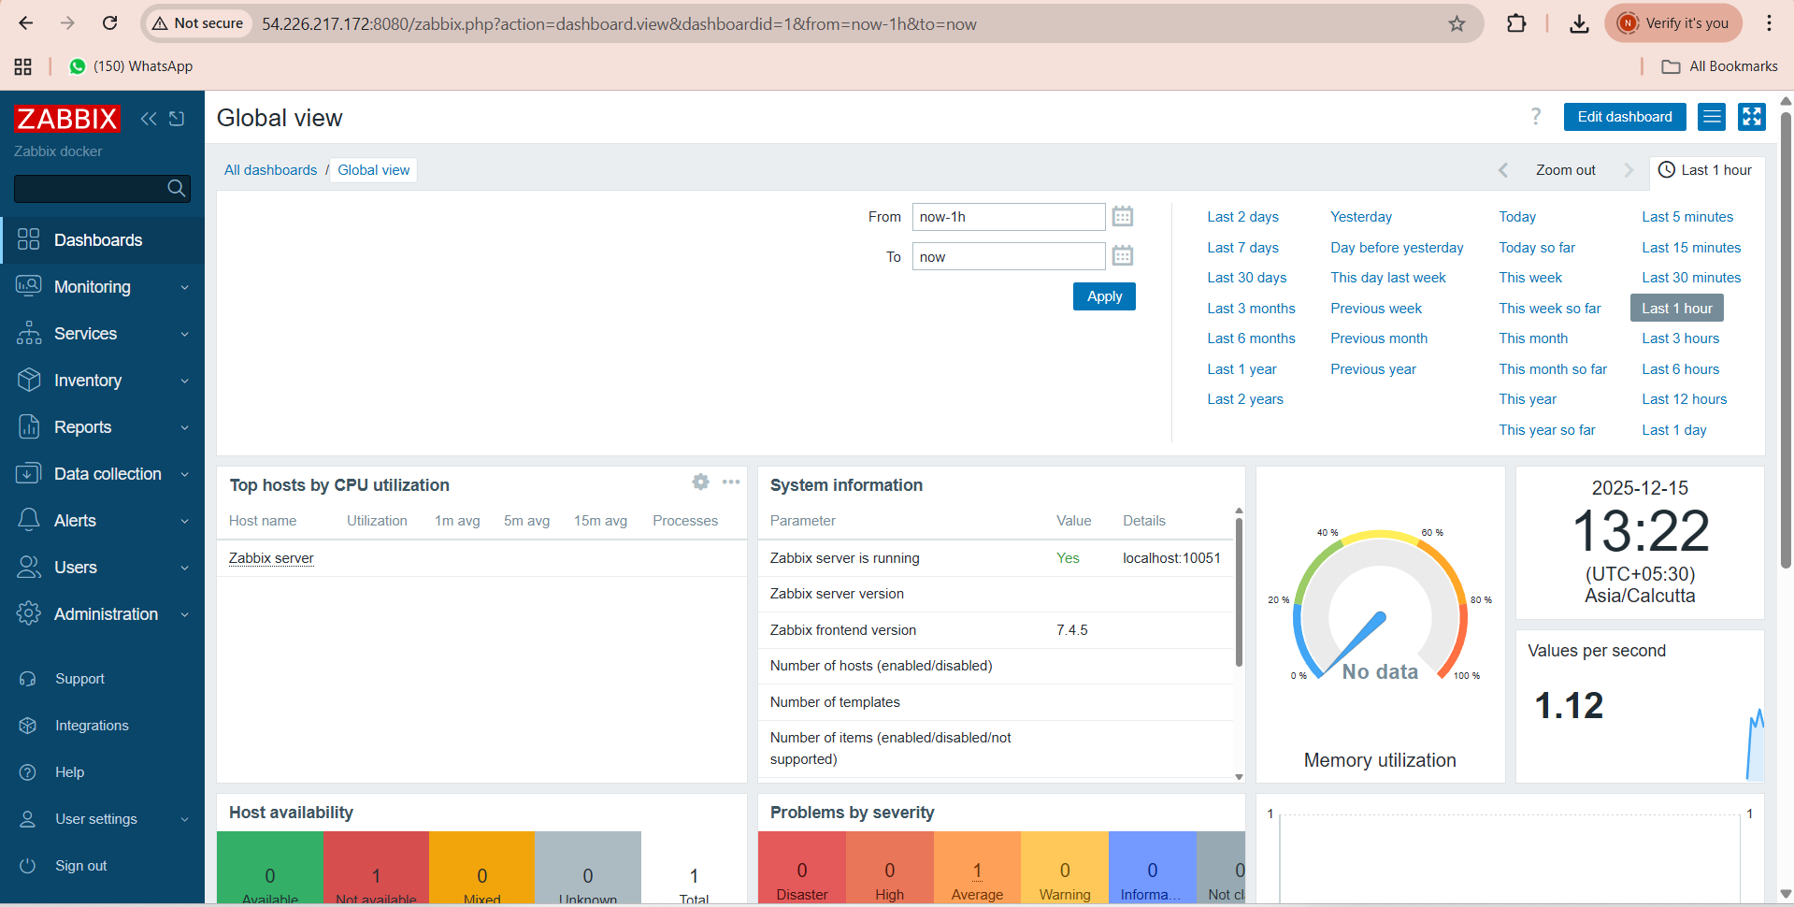
STEP 9: Change Default Admin Password (Important)Go to Users → Users
- Click Admin
- Change password
- Save
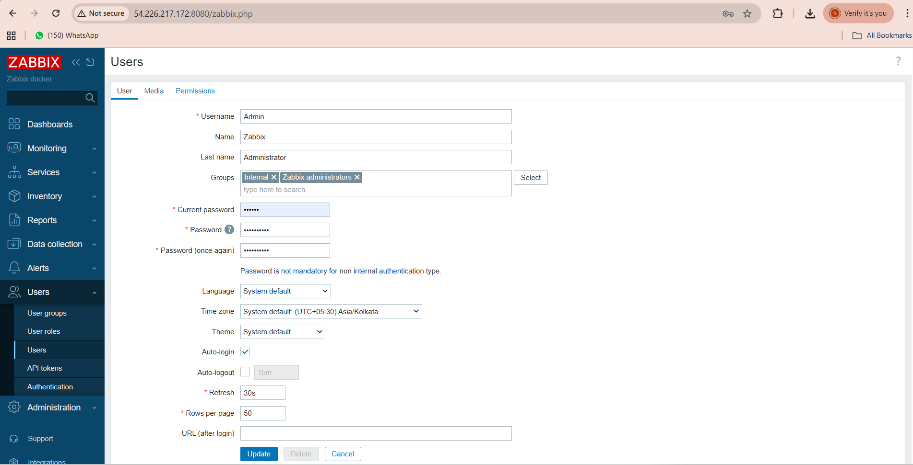
INSTALL ZABBIX AGENT ON SAME EC2
STEP 10: Check Ubuntu Version
lsb_release -a
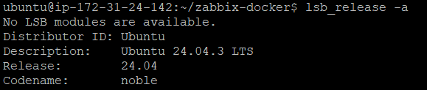
STEP 11: Add Zabbix GPG Key
curl -fsSL https://repo.zabbix.com/zabbix-official-repo.key | sudo gpg --dearmor -o /usr/share/keyrings/zabbix.gpg
STEP 12: Add Zabbix Repository (Jammy)
echo "deb [signed-by=/usr/share/keyrings/zabbix.gpg] https://repo.zabbix.com/zabbix/7.0/ubuntu jammy main" | sudo tee /etc/apt/sources.list.d/zabbix.list
Using jammy repo on noble (24.04) is safe and recommended.
STEP 13: Update Packages
sudo apt update
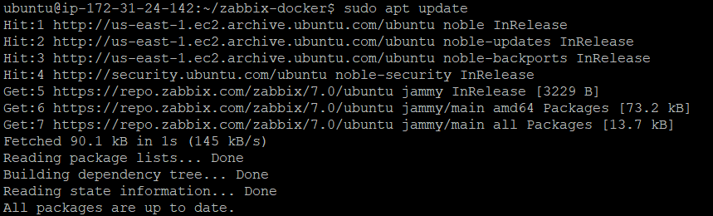
STEP 14: Zabbix Agent Installation (EC2 Host)
sudo apt install zabbix-agent2 -y
Verify:
zabbix_agent2 -V
STEP 15: Agent Configuration
sudo nano /etc/zabbix/zabbix_agent2.conf
Set:
Server=127.0.0.1,172.31.0.0/16,172.17.0.0/16,172.18.0.0/16
ServerActive=127.0.0.1
Hostname=Zabbix-EC2-Server
Save & exit.
STEP 16: Start & Enable Agent
sudo systemctl restart zabbix-agent2
sudo systemctl enable zabbix-agent2

Verify Agent Connectivity
docker exec -it zabbix-server zabbix_get -s <EC2_PRIVATE_IP> -k system.hostname
Expected:
Zabbix-EC2-Server
Check:
sudo systemctl status zabbix-agent2
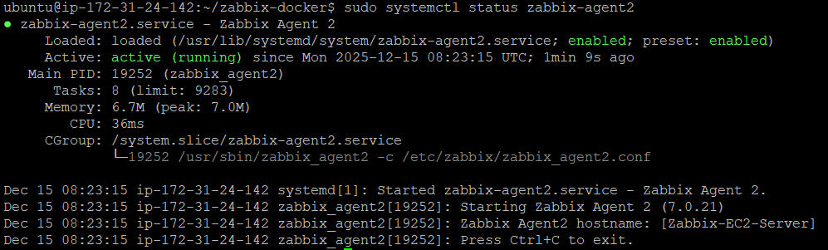
STEP 17: Verify Agent Port
sudo ss -tulnp | grep 10050
ADD HOST IN ZABBIX UI
STEP 18: Create Host
- Configuration → Hosts → Create host
- Host name: Zabbix-EC2-Server
- Group: Linux servers
- Interface: Agent
- IP: EC2 Private IP
- Port: 10050
- Template: Linux by Zabbix agent
- Click Add
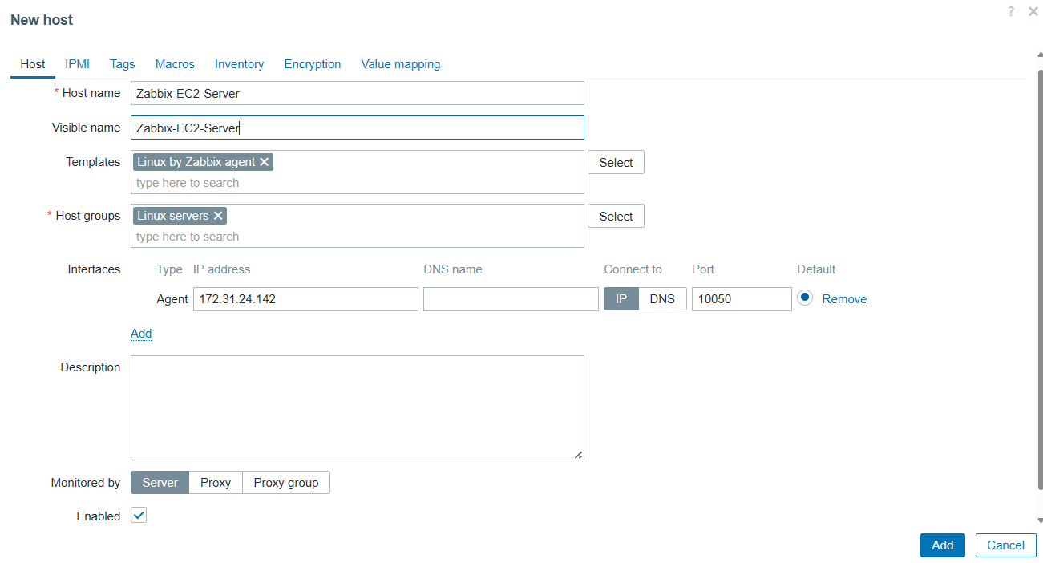
STEP 19: Verify Host Status
- Go to Data collection → Hosts
- ZBX should be Green ✅
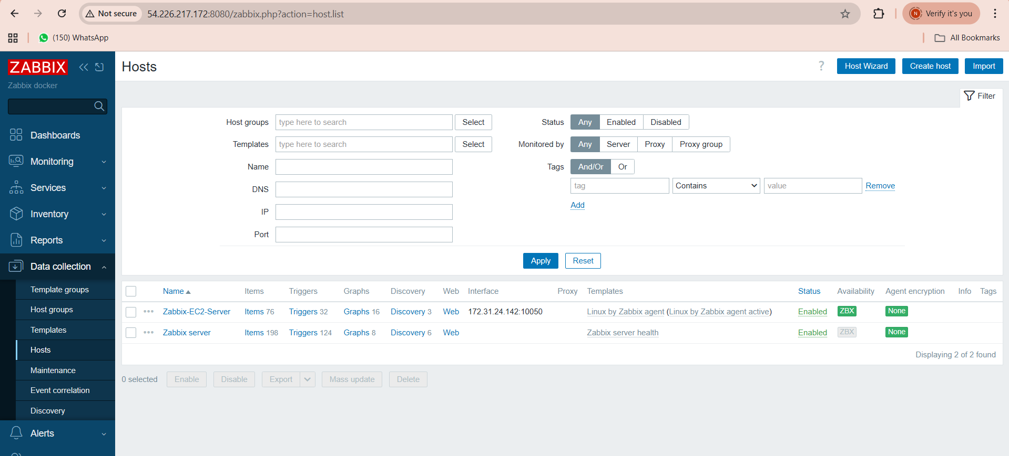
Alerting & Trigger Configuration
Disk, CPU, and memory alerts are provided by the"Linux by Zabbix agent" template using discovery rules.
CREATE BASIC ALERTS (CPU, Memory, Disk)
CPU High Usage Alert
Go to:
Data collection → Hosts → Zabbix-EC2-Server → Triggers → Create trigger
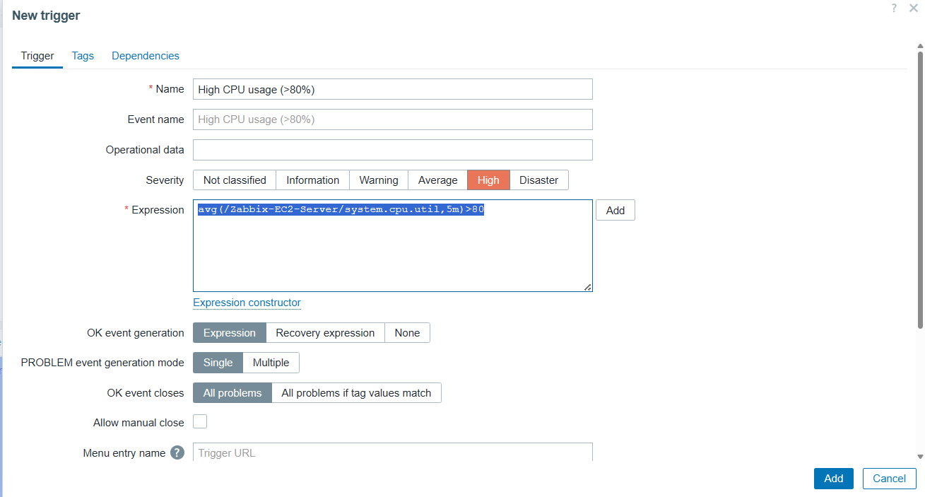
Verify
Go to:
Monitoring → Problems
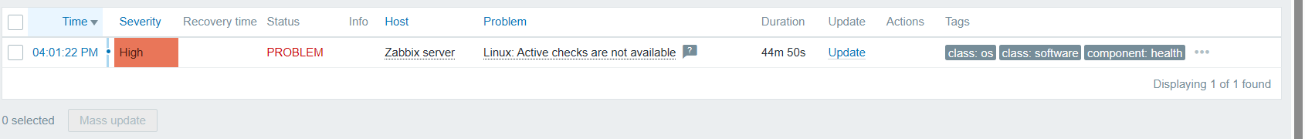
DISABLE UNUSED TRIGGER
- Data collection → Hosts → Zabbix server → Triggers
- Disable: Linux: Active checks are not available
Memory Alert (Low Available Memory)
Step 1: Go to Trigger creation
Data collection → Hosts → Zabbix-EC2-Server → Triggers → Create trigger
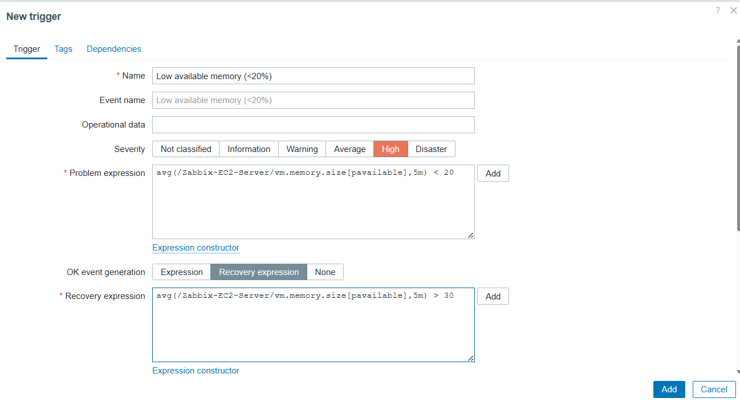
MEMORY ALERT(High memory usage)
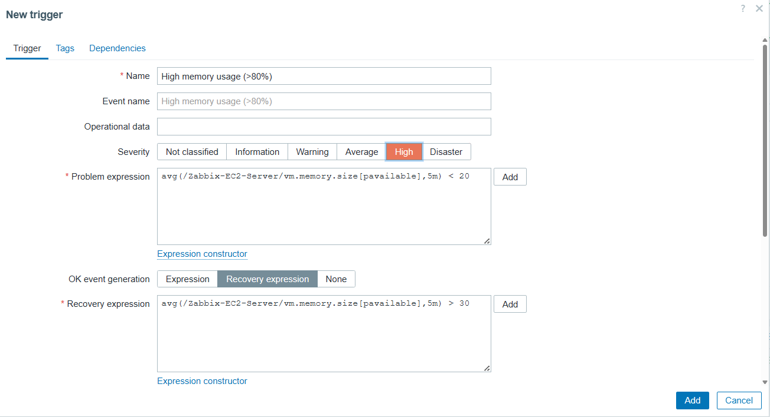
Disk Space Alert (Low Disk Available)
Open Trigger creation
Data collection → Hosts → Zabbix-EC2-Server → Triggers → Create trigger
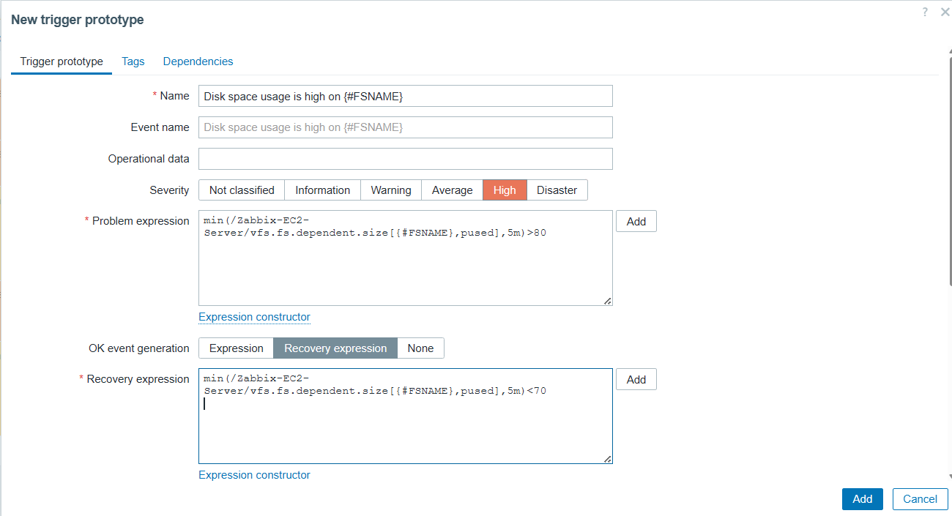

EMAIL ALERT CONFIGURATION (GMAIL SMTP)
STEP 20: Configure Media Type
Configure Email Media Type (SMTP)
Alerts → Media types → Email / Gmail SMTP
Authentication: Username & Password
Username: your Gmail ID
Password: Google App Password (16 chars)
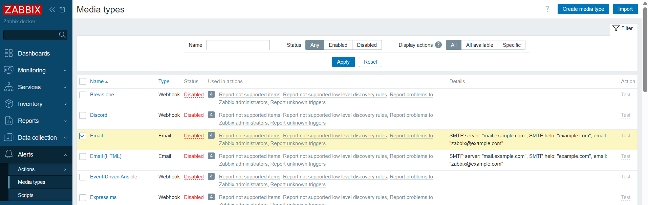
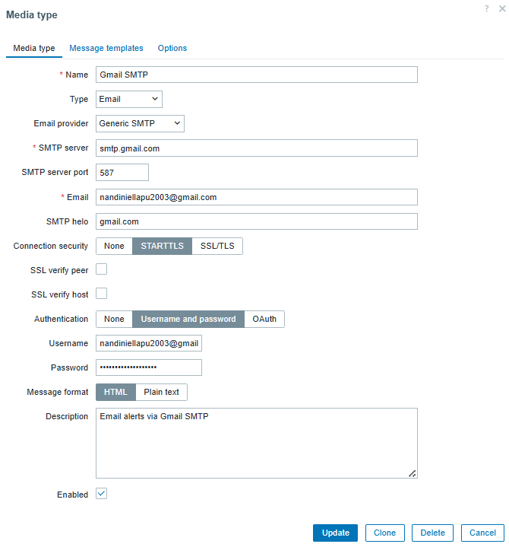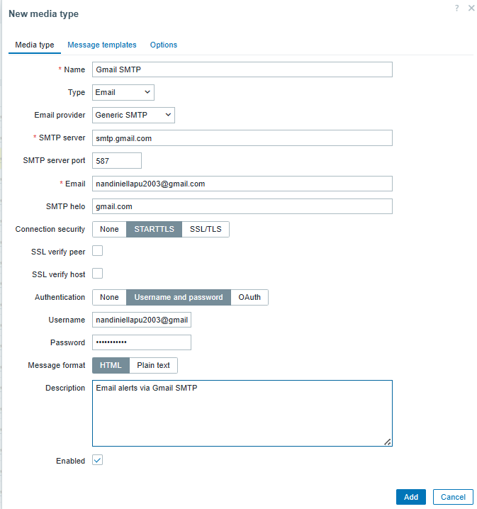

- Go to
Alerts → Media types
- Click Gmail SMTP (the one that is Enabled in your list)
- Scroll to the Authentication section
- Set it like this:
Authentication settings
- Authentication → Username and password
- Username → your Gmail ID
- Password → 🔑 PASTE THE GOOGLE APP PASSWORD HERE
(the 16-character password Google gave you)
- Send Test Mail

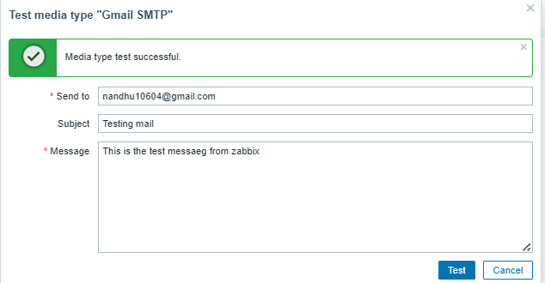
Check Test Mail Received Or not
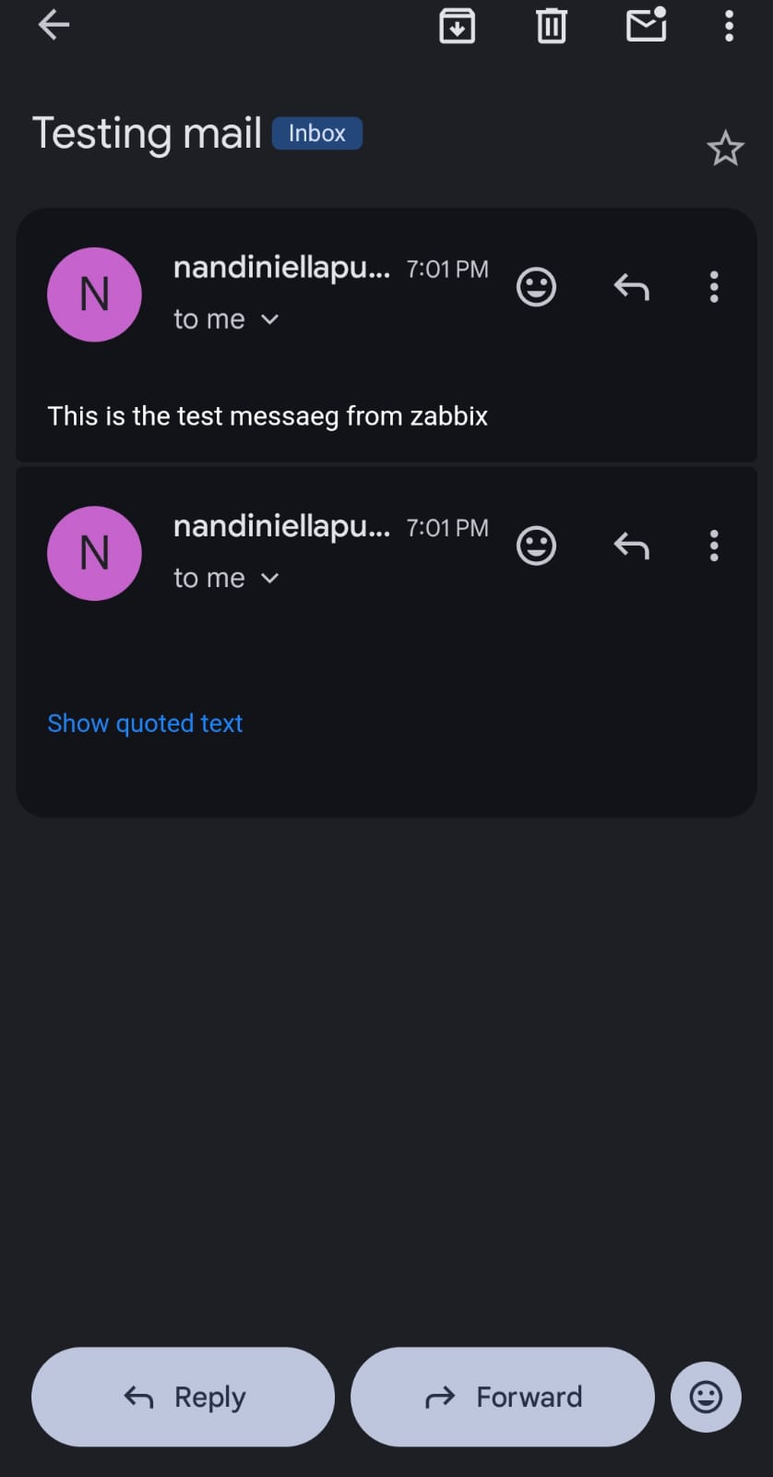
STEP 21: Create Action
- Configuration → Actions → Trigger actions
- Name: Send email alerts
- Condition: Trigger severity >= Warning
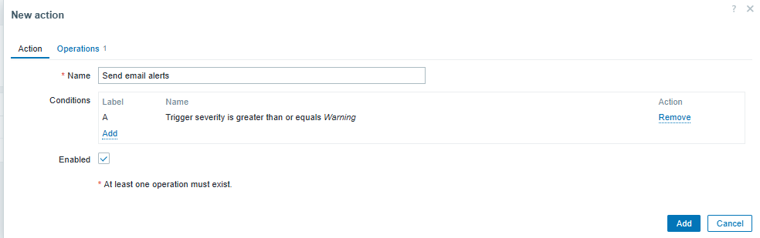

Operations
- Operation type: Send message
- Media type: Gmail SMTP
Subject:
{TRIGGER.STATUS}: {TRIGGER.NAME}
Message:
Problem: {TRIGGER.NAME}
Status: {TRIGGER.STATUS}
Severity: {TRIGGER.SEVERITY}
Host: {HOST.NAME}
IP: {HOST.IP}
Time: {EVENT.DATE} {EVENT.TIME}
Value: {ITEM.LASTVALUE}
Click Add
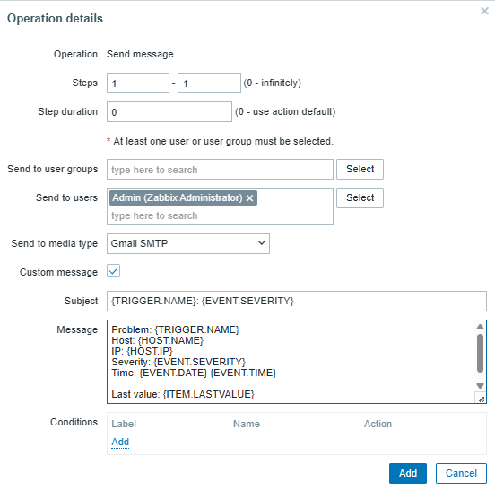
STEP 22: Recovery Message
Add Recovery operation → Send message
Message:
RECOVERED: {TRIGGER.NAME}
Host: {HOST.NAME}
Time: {EVENT.RECOVERY.DATE} {EVENT.RECOVERY.TIME}
STEP 23: Verify User Email Media
- Administration → Users → Admin → Media
- Type: Gmail SMTP
- Type: Gmail SMTP
- Send to: your email (example: XXXXXXXXXXX@gmail.com)
- When active: 1-7,00:00-24:00
- Use if severity: ✔ Warning, Average, High, Disaster
- Status: Enabled
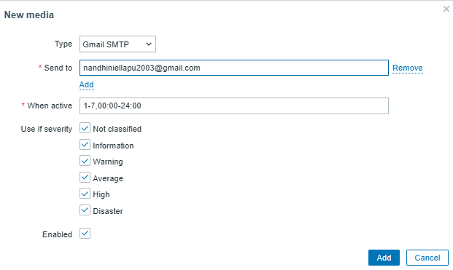
FINAL TEST (REAL ALERT)
Check which filesystem Zabbix is monitoring
In Zabbix UI:
Monitoring → Hosts → Zabbix-EC2-Server → Latest data
Search for:
Space: Used, in %
disk is 99.16% USED on /
That means Zabbix is collecting data correctly
Confirm disk usage on the server
Run this on the server:
df -h
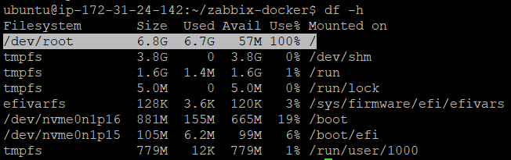
- Root filesystem / is 100% full
- Available space is only 57 MB
- Zabbix item already shows:
FS [/]: Space: Used, in % ≈ 99–100%
This must trigger your disk alert.
Validation Test (Mandatory)
sudo fallocate -l 1G /tmp/zabbix-test
Expected:
Alert visible in Monitoring → Problems
Email notification received

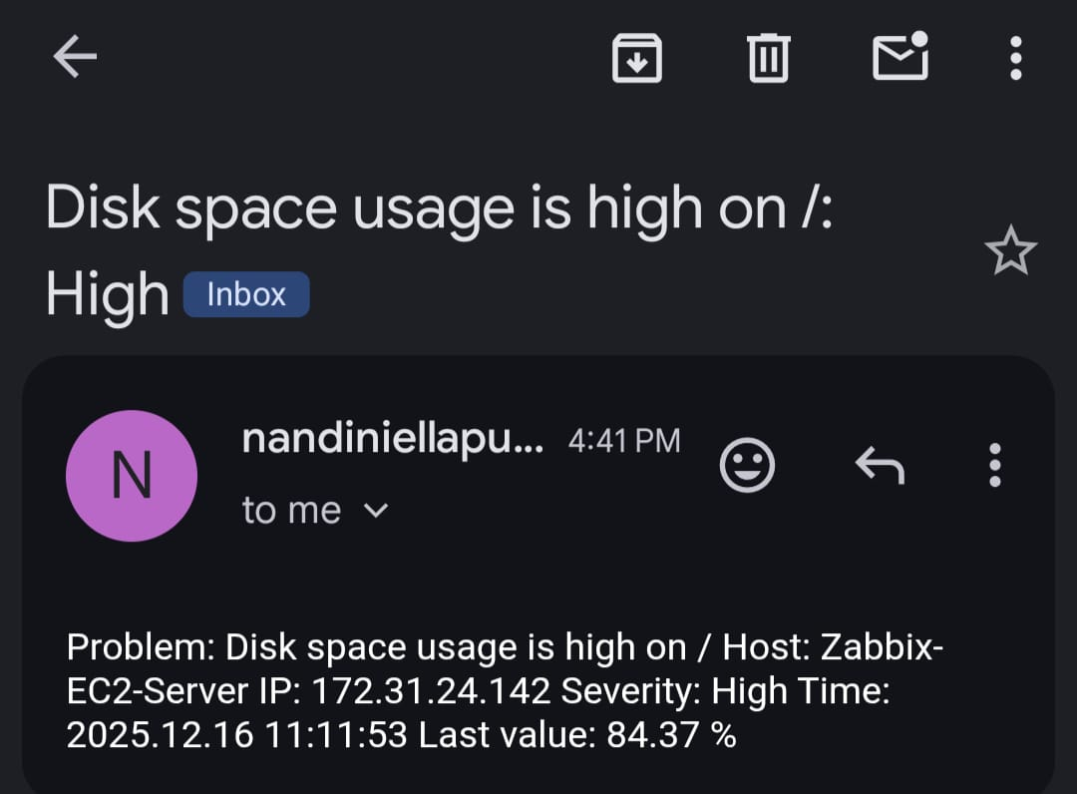
Recovery:
sudo rm -f /tmp/zabbix-test
Expected:
- Alert resolved
- Recovery email received

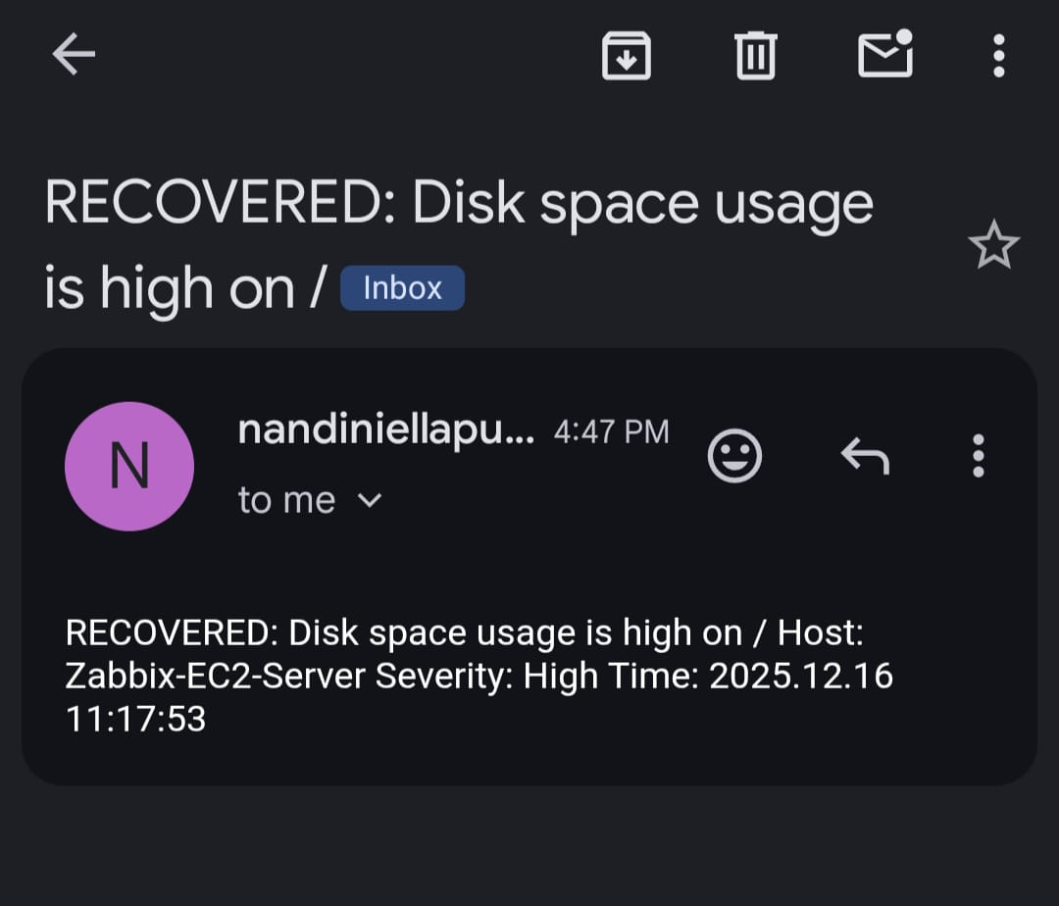
This setup provides a secure, scalable monitoring solution using Zabbix with Docker. It has been validated with real alerts and email notifications and can be reused by teams across environments.

